**Name: Keerthana Dinesh A**

**Roll No:11**

**Batch: S2 MCA B**

**Date:06/06/2022**

**NETWORKING & SYSTEM ADMINISTRATION LAB**

**Experiment No: 28**

**Aim**

**Build and install software from source code, familiarity with make and cmake utilities expected.**

**Procedure**

1. We can obtain information of a package and its dependencies using the apt command. Doing that for cmake:

**$ apt show cmake**

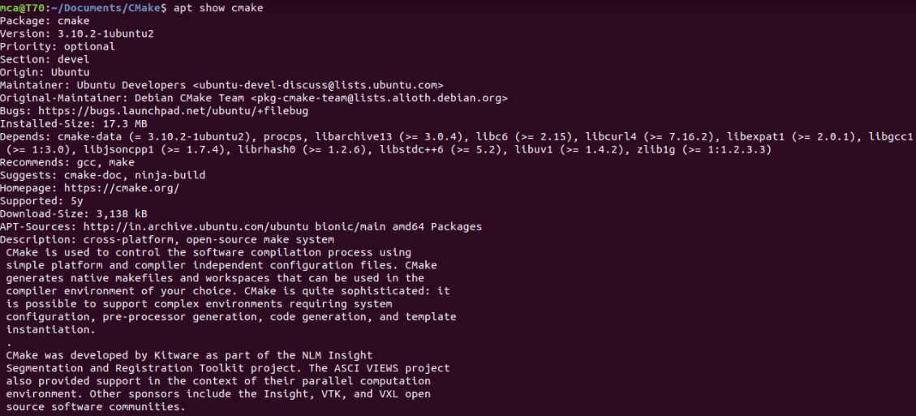

1. To install cmake , g++ and make using the apt command, type:

**$ sudo apt install cmake g++ make**

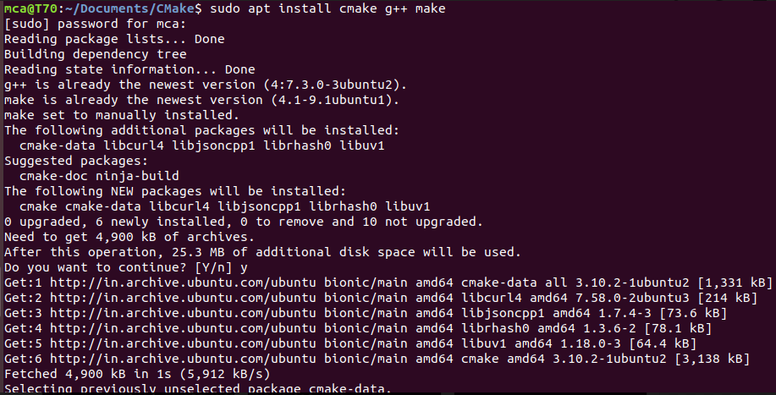

**A Sample CMake project**





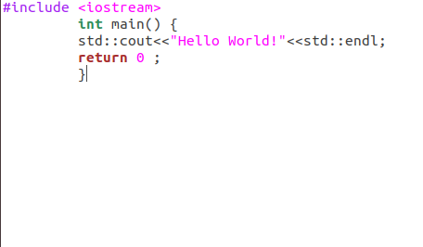

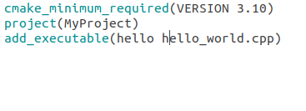

A directory to which CMake was executed is called “Built Directory”

